University of Hull

# Understanding AI (Resit Assignment)

## Mohammad Areez Khan

## 202123678

**Contents**

**Component 1 create agent in AI** 2

Office productivity 2

Climate change 3

Hazardous environment (chemical) 4

Human balance analysis 6

Cancer detection 6

Physical theft prevention 8

Brain surgery 9

**Component 2 Fuel Consumption rating** 10

**Component 3 Emergency Vehicle Identification Using Fast AI** 22

**Component 4 Identify five ethical challenges in AI systems** 26

# **Component 1 create agent in AI**

## Office productivity

1. Agent:

* The AI agent is a software program designed to assist users in office-related tasks.
* It can be deployed on desktop computers, mobile devices, or integrated into existing office applications.
* The agent utilizes natural language processing (NLP), machine learning, and other AI techniques to understand and respond to user queries and commands.

1. Goals:

* The primary goal of the AI agent is to enhance office productivity by assisting users in various tasks.
* The agent aims to improve efficiency, accuracy, and effectiveness in completing office-related activities.
* Specific goals may include managing schedules, organizing documents, providing information, and facilitating communication.

1. Actions:

* The AI agent can perform a range of actions to assist users, including:
* Scheduling: The agent can add, modify, or delete events on a user's calendar, send reminders, and manage meeting invitations.
* Document Management: The agent can create, open, save, and edit documents, spreadsheets, presentations, and other office files.
* Information Retrieval: The agent can search for information within documents, databases, or the internet, and provide relevant results to the user.
* Communication: The agent can send and receive emails, manage contacts, initiate video or audio calls, and provide voice-based assistance.
* Task Management: The agent can help users track and prioritize tasks, set deadlines, and provide reminders.
* Workflow Automation: The agent can automate repetitive tasks, such as generating reports, data entry, or file organization.

1. External Factors:

* User Input: The AI agent interacts with users through text, voice, or graphical interfaces, understanding natural language queries and commands.
* Office Applications: The agent integrates with existing office applications like email clients, document editors, calendars, and messaging platforms.
* Data Sources: The agent can access relevant data sources, such as calendars, documents, emails, contacts, and external APIs for information retrieval.
* Internet Connectivity: The agent relies on internet connectivity to access online resources, perform web searches, and communicate with cloud services if necessary.

## Climate change

1. Performance Measure:

* The performance measure for the AI agent could be reducing greenhouse gas emissions, promoting sustainable practices, and mitigating the impacts of climate change.
* The agent's effectiveness can be measured by tracking metrics such as the reduction in carbon dioxide emissions, adoption of renewable energy sources, increase in energy efficiency, or positive changes in public awareness and behavior towards climate-related issues.

2. Environment:

* The environment of the climate change AI agent includes various factors associated with climate change and its effects, as well as the human and natural systems affected by it.
* It encompasses both physical and social aspects, such as weather patterns, temperature changes, sea-level rise, natural disasters, energy consumption, transportation systems, industrial processes, agricultural practices, and public policy frameworks.
* The agent operates in a dynamic environment, influenced by scientific research, political decisions, public opinion, technological advancements, and socio-economic factors.

3. Actuators:

* The actuators of the climate change AI agent involve the mechanisms and actions it can take to address climate change.
* The agent can engage in a wide range of activities, including:
* Providing information and education: The agent can disseminate knowledge about climate change, its causes, impacts, and potential solutions to individuals, communities, and organizations.
* Policy analysis and recommendation: The agent can analyze climate policies, propose improvements, and offer recommendations to policymakers based on scientific research and data analysis.

4. Sensors:

* The sensors of the climate change AI agent collect data from the environment and provide information for analysis and decision-making.
* The agent can utilize a variety of sensors and data sources, including satellite imagery, weather stations, environmental sensors, energy consumption data, social media, scientific publications, and reports from relevant organizations.
* The agent can employ machine learning algorithms to process and analyze the collected data, identify patterns, forecast future trends, and make informed recommendations.

## Hazardous environment (chemical)

1. Gas Concentrations:

* The agent's sensors can detect and measure the concentrations of various gases present in the environment, such as toxic or flammable gases.
* Percepts may include the concentration levels of specific chemicals or the presence of hazardous gases exceeding safety thresholds.

2. Temperature and Pressure:

* The agent's sensors can provide information about the temperature and pressure conditions in the environment.
* Percepts may include the ambient temperature, temperature variations, or pressure changes that could impact chemical reactions or safety measures.

3. Hazardous Material Labels:

* The agent's sensors can capture visual or textual information from hazardous material labels on containers or equipment.
* Percepts may include the identification of specific chemicals, their hazard classifications, or any warning labels indicating potential dangers.

4. Emergency Alarms and Alerts:

* The agent can receive real-time alerts or notifications from the environment's safety systems.
* Percepts may include audible or visual alarms, emergency messages, or notifications related to safety breaches, leaks, or critical incidents.

5. Equipment and Instrumentation Status:

* The agent's sensors can monitor the status and functioning of safety equipment, such as gas detectors, ventilation systems, or emergency shutdown mechanisms.
* Percepts may include the operational status, maintenance needs, or failures of such safety equipment.

6. Environmental Parameters:

* The agent's sensors can provide information about environmental factors that could influence chemical processes or safety conditions.
* Percepts may include humidity levels, ambient light conditions, air quality, or any other relevant environmental parameters.

7. Human Activities and Interactions:

* The agent's sensors or cameras can observe and interpret human actions and interactions in the environment.
* Percepts may include the presence of workers, their movements, safety protocols being followed or violated, or any signs of distress or urgency.

## Human balance analysis

1. Perturbations:

* Perturbations are external disturbances that challenge or disrupt a person's balance.
* The agent can be triggered to analyze and respond to these perturbations by perceiving sudden changes in the person's body position or movements.
* Perturbations can be introduced in different ways, such as pushing or pulling the person, applying unexpected forces or torques, or creating an unstable surface for them to stand on.

2. Changes in Surface Conditions:

* Changes in the surface conditions on which a person is standing can significantly affect their balance.
* The agent can be triggered to analyze and adapt to these changes by perceiving alterations in the surface properties.
* Examples of surface condition changes include transitioning from a stable to an unstable surface, encountering slippery or uneven terrain, or walking on surfaces with different levels of friction.

## Cancer detection

1. Medical Data and Information:

* The environment includes various types of medical data and information related to cancer, such as patient records, medical images (e.g., X-rays, MRIs), pathology reports, genetic data, and clinical notes.
* The agent relies on this data to analyze and detect patterns or abnormalities indicative of cancer.

2. Diagnostic Equipment and Tools:

* The environment may consist of diagnostic equipment and tools used in cancer detection, including imaging machines, laboratory equipment for analyzing tissue samples, genetic testing devices, and other medical instruments.
* The agent may interact with these tools to access or analyze data, interpret results, or integrate with existing healthcare systems.

3. Healthcare Professionals and Patients:

* The agent interacts with healthcare professionals, including doctors, radiologists, pathologists, and oncologists, who provide expertise and collaborate in the cancer detection process.
* Patients are also part of the environment, as their medical records, test results, and health histories are essential for accurate cancer detection.

4. Ethical and Privacy Considerations:

* The environment involves ethical and privacy considerations due to the sensitive nature of medical data.
* The agent must adhere to legal and regulatory requirements for data privacy and confidentiality, ensuring that patient information is securely handled and accessed only by authorized personnel.

5. Scientific Research and Knowledge:

* The environment incorporates the latest scientific research, clinical guidelines, and medical knowledge related to cancer detection.
* The agent leverages this information to stay updated, learn from new studies, incorporate emerging techniques, and continuously improve its accuracy and performance.

6. Data Quality and Availability:

* The environment's data quality and availability can vary, posing challenges for the agent's training and performance.
* The agent may need to address issues like missing data, data inconsistencies, or variations in data quality across different healthcare institutions or regions.

## Physical theft prevention

1. Simple Reflex Agent:

* A simple reflex agent operates based on a set of predefined rules or conditions and takes immediate actions based solely on the current percept.
* In the case of theft prevention, the agent might respond to specific sensor inputs, such as detecting unauthorized access to a restricted area, and trigger an immediate response, such as sounding an alarm or notifying security personnel.

2. Model-Based Agent:

* A model-based agent maintains an internal model or representation of the environment and uses this model to plan and make decisions.
* In the context of theft prevention, the agent may have a model of the building layout, security systems, and known vulnerabilities. It can use this model to simulate different scenarios, predict potential theft risks, and take proactive measures to enhance security in vulnerable areas.

3. Goal-Based Agent:

* A goal-based agent operates by setting explicit goals or objectives and takes actions to achieve those goals.
* In theft prevention, the agent could have goals such as reducing the number of theft incidents or minimizing the time taken to respond to security breaches. It would take actions aligned with these goals, such as deploying security personnel in high-risk areas or implementing surveillance technologies in strategic locations.

4. Utility-Based Agent:

* A utility-based agent aims to maximize an overall utility or value function that quantifies the desirability of different outcomes.
* In theft prevention, the agent could assign utility values to various actions and outcomes. For example, it might prioritize responses that minimize property damage or maximize the likelihood of apprehending the thief. The agent would select actions that optimize the utility function, considering the potential consequences and trade-offs.

5. Learning Agent:

* A learning agent can improve its performance over time by learning from experience and adapting its behavior based on feedback.
* In the context of theft prevention, the agent might employ machine learning techniques to analyze historical theft data, identify patterns, and develop predictive models. It can continuously learn from new data to refine its detection capabilities, adapt to evolving theft techniques, and improve its effectiveness in preventing theft incidents.

## Brain surgery

1. Preoperative Planning:

* The AI agent can analyze preoperative imaging data, such as MRI or CT scans, to assist in surgical planning.
* It can help identify critical brain structures, tumor boundaries, or anomalies, providing insights to aid in surgical strategy development.

2. Surgical Navigation and Guidance:

* During surgery, the AI agent can provide real-time guidance and navigation assistance to the surgeon.
* It can integrate with advanced imaging technologies, such as intraoperative MRI or neuronavigational systems, to help accurately locate and target specific regions of the brain.

3. Decision Support:

* The AI agent can analyze the patient's vital signs, surgical data, and real-time feedback to provide decision support to the surgeon.
* It can offer recommendations on the optimal surgical approach, adjusting for patient-specific factors and potential risks.

4. Tumor Detection and Segmentation:

* The AI agent can analyze intraoperative images or sensor data to detect and segment tumor regions.
* It can assist in differentiating tumor tissue from healthy brain tissue, helping the surgeon achieve more precise tumor resection.

5. Procedural Safety:

* The AI agent can monitor various parameters during the surgery, such as brain activity, blood flow, or tissue response, to identify potential risks or complications.
* It can provide real-time alerts or warnings to the surgeon, facilitating timely intervention and enhancing procedural safety.

6. Surgical Training and Skill Enhancement:

* The AI agent can be utilized for training purposes, allowing surgeons to practice and improve their skills in a simulated environment.
* It can provide virtual surgical simulations, feedback on performance, and guidance for skill development.

7. Ethical and Legal Considerations:

* Designing an AI agent for brain surgery requires careful attention to ethical and legal aspects.
* Patient privacy, data security, regulatory compliance, and the responsibility for decision-making must be addressed to ensure patient safety and maintain ethical standards.

# **Component 2 Fuel Consumption rating**

Describe the steps required to train a model.

To train a model for fuel consumption rating using machine learning, you would generally follow these steps:

1. Data Collection: Gather a dataset that includes relevant features and the corresponding fuel consumption ratings. The dataset should be representative and cover a wide range of scenarios, such as different vehicle types, engine sizes, driving conditions, and fuel types.

2. Data Preprocessing: Clean the data by handling missing values, outliers, and inconsistencies. Normalize or scale numerical features to ensure they are on a similar scale. Encode categorical variables into numerical representations if needed.

3. Feature Selection/Engineering: Analyze the dataset and select the most informative features that are likely to influence fuel consumption. You may also need to engineer new features based on domain knowledge or transformation techniques to enhance the model's performance.

4. Train/Test Split: Divide the dataset into training and testing sets. The training set is used to train the model, while the testing set is used to evaluate its performance. A common split ratio is 70-30 or 80-20, but it can vary depending on the dataset size.

5. Model Selection: Choose an appropriate machine learning algorithm for the problem at hand. For fuel consumption rating, regression algorithms such as linear regression, decision trees, random forests, or gradient boosting methods like XGBoost or LightGBM could be suitable options.

6. Model Training: Feed the training data into the selected model and optimize its parameters using a suitable optimization algorithm. The model learns patterns and relationships between the features and the fuel consumption ratings during this phase. The process involves minimizing a loss function that quantifies the discrepancy between predicted and actual fuel consumption ratings.

7. Model Evaluation: Use the testing set to assess the model's performance. Common evaluation metrics for regression tasks include mean squared error (MSE), root mean squared error (RMSE), mean absolute error (MAE), or R-squared (coefficient of determination). These metrics provide insights into how well the model generalizes to unseen data.

8. Hyperparameter Tuning: Fine-tune the model by adjusting hyperparameters. Hyperparameters control the model's behavior and performance. Use techniques like grid search, random search, or Bayesian optimization to find the optimal combination of hyperparameters that yield the best results.

9. Model Validation: Validate the final model's performance on a separate validation set or through cross-validation. This step helps ensure that the model's performance is not overfitting to the testing set and can generalize well to new, unseen data.

**Load libraries of python**

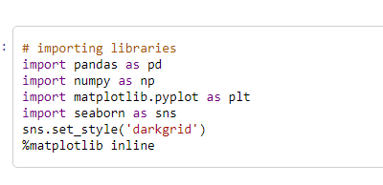

This code imports the necessary libraries for data analysis and visualization in Python.

import pandas as pd imports the panda’s library, which provides data structures and data analysis tools.

import numpy as np imports the numpy library, which provides support for arrays and mathematical functions.

import matplotlib. pyplot as plt imports the pyplot module from the matplotlib library, which allows for data visualization.

import seaborn as sns imports the seaborn library, which provides a high-level interface for drawing attractive and informative statistical graphics.

sns.set_style('darkgrid') sets the grid style for seaborn plots to a dark grid.

%matplotlib inline enables the display of matplotlib plots within the Jupyter notebook.

Attempt to use all the numerical continuous variables in the dataset provided to build a model to predict the CO2 emission. Perform exploratory data analysis to select a subset of the variables and repeat the procedure. Compare your models and report if there are any differences in the models’ performances? Explain your findings.

**Load Dataset and explain variables**

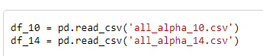

This code reads two CSV files, 'all_alpha_10.csv' and 'all_alpha_14.csv', using the read_csv () function from the panda’s library. The data from each file is stored in separate pandas DataFrame objects named df_10 and df_14, respectively.

2010 year

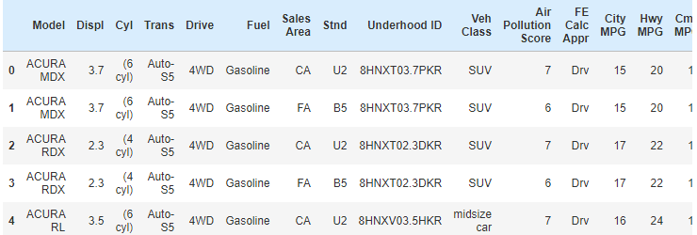

2014 year

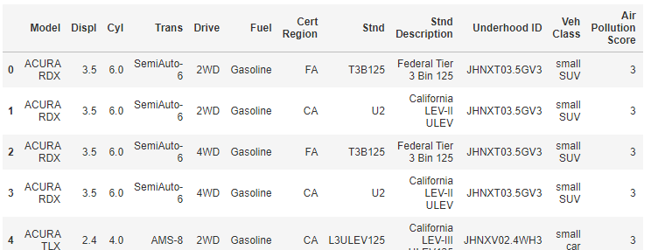

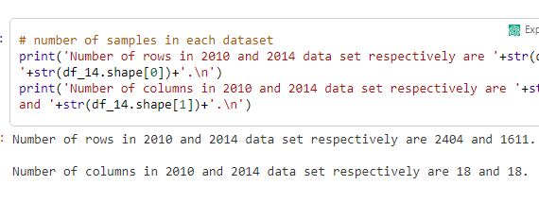

Missing values check

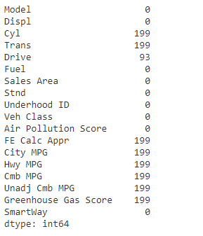 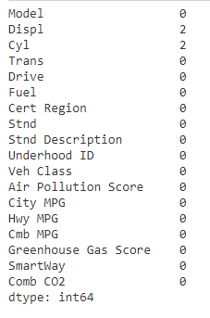

The Brazilian dataset can be used to predict fuel consumption using a Support Vector Machine (SVM) prediction model. Four phases are involved: Data Preprocessing, Feature Weighting, Feature Selection, and SVM Prediction Model. Data preprocessing involves cleaning and transformation tasks, while feature weighting assigns weights to influential features based on their importance in the prediction model. Feature selection identifies the most relevant features, reducing dimensionality, improving model performance, and reducing computational requirements. The SVM Prediction Model predicts fuel consumption based on selected features, learning from the labeled dataset and finding the best hyperplane to separate data points. The success of the project depends on factors such as dataset quality, appropriate feature engineering, and tuning of the SVM model's hyperparameters.

**Determine whether there were any noticeable improvements in the CO2 emission from year 2010 to year 2014? Explain your findings.**

This Python code is using the matplotlib library to create a histogram of the 'greenhouse_gas_score' column from a dataframe named 'df_10'.

plt. hist(df_10['greenhouse_gas_score']) creates the histogram, using the values from the 'greenhouse_gas_score' column as the input.

plt. title ('Histogram greenhouse gas score 2010') sets the title for the histogram graph as 'Histogram greenhouse gas score 2010'.

plt. xlabel ('greenhouse gas score') sets the label for the x-axis of the histogram as 'greenhouse gas score'.

plt. ylabel('Count') sets the label for the y-axis of the histogram as 'Count'.

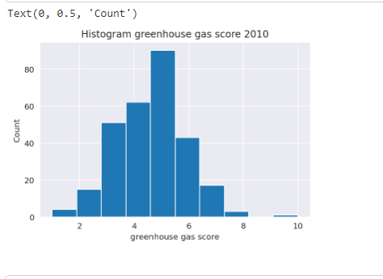

The code provided is using the matplotlib. pyplot library in Python to create a histogram of the data in the 'greenhouse_gas_score' column of a DataFrame called df_14.

Here's a breakdown of the code:

plt. hist(df_14['greenhouse_gas_score']) creates a histogram of the values in the 'greenhouse_gas_score' column.

plt. title ('Histogram greenhouse gas score 2014') sets the title of the histogram plot to 'Histogram greenhouse gas score 2014'.

plt. xlabel ('greenhouse gas score') sets the label for the x-axis to 'greenhouse gas score'.

plt. ylabel('Count') sets the label for the y-axis to 'Count'.

Overall, this code visualizes the distribution of the 'greenhouse_gas_score' values and provides a title and axis labels for the plot.

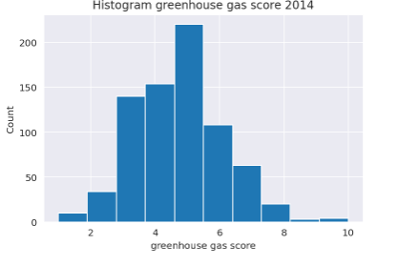

Using each categorical variable as the target variable at each instance, determine which of the variables performed best in classifying the dataset. Explain your findings.

The code df_10. smartway.value_counts () are calling the value_counts () function on the smartway column of the DataFrame df_10. It will return the count of unique values in the smartway column and display them in descending order.

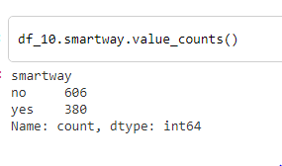

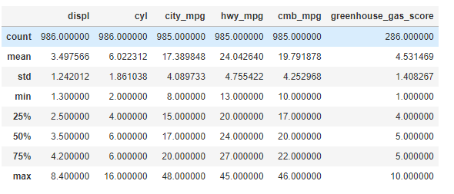

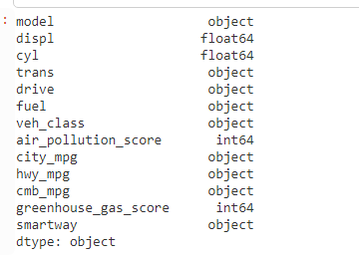

he dtypes attribute is used to get the datatypes of each column in the DataFrame.

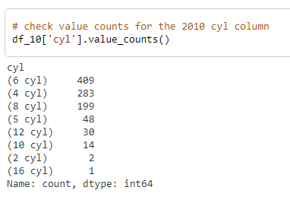

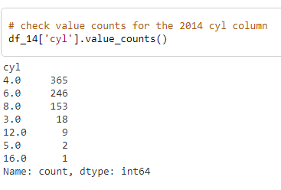

**How did you check whether your models did not overfit?**

To assess a model's performance on fuel consumption data, we use techniques like Train-Test Split, Cross-Validation, Evaluation Metrics, Regularization Techniques, and Learning Curves. These techniques help identify overfitting by dividing the dataset into a training set and a test set. If the model performs better on the training set but poorly on the validation set, it suggests overfitting. Regularization techniques, like L1 or L2 regularization, can help prevent overfitting by adding a penalty term to the model's objective function. Learning curves can provide insights into overfitting by showing the model's performance on the training and validation sets. Monitoring and evaluating model performance on independent data is crucial to detect and address overfitting issues.

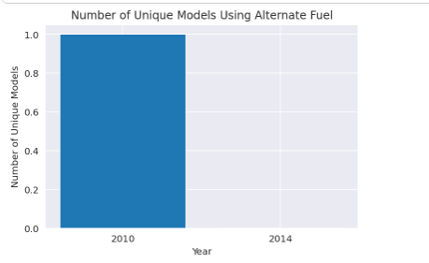

State the performance measure(s) you were most interested in and the reason(s).

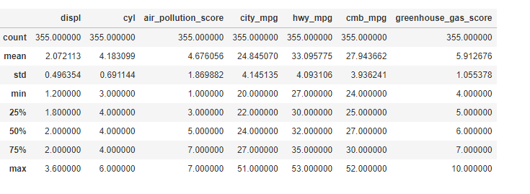

It selects rows from a DataFrame called df_14 where the value of the column cmb_mpg is greater than the mean value of cmb_mpg. This is done using the query () method. The selected rows are assigned to a new DataFrame called top_14.

It then calls the describe () method on the top_14 DataFrame. This method generates summary statistics of the data in top_14 and displays the result.

Can your models be deployed based on their performances? Explain.

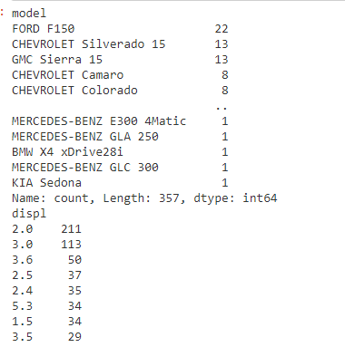 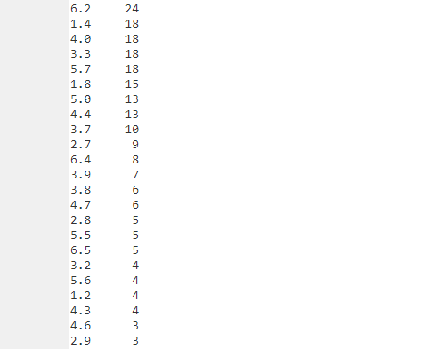 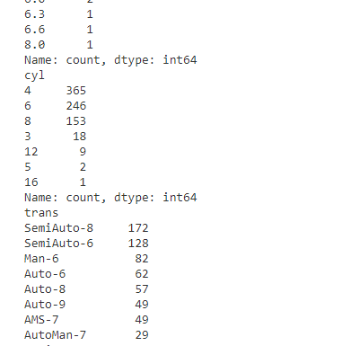 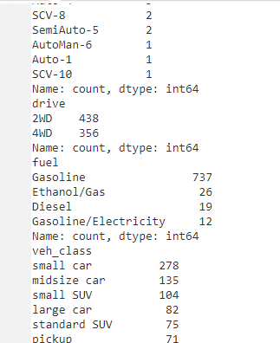

In this code, the df_10. columns attribute returns a list of column names in the Data Frame df_10. The loop then iterates over each column name, and within each iteration, df_10[col_name] is used to access the specific column.

The value_counts () function is a Pandas function that can be applied to a Series (a single column of the DataFrame) to count the occurrences of each unique value within that column. It returns a Series object where the unique values are the index, and the corresponding counts are the values.

By using df_10[col_name], you access the specific column in each iteration of the loop. Then, value_counts () is applied to that column, returning the value counts for that column. The loop prints the column name, the value counts, and adds a separator to differentiate between different columns.

This code snippet is useful for quickly understanding the distribution of values within each column of the Data Frame and gaining insights into the data.

# **Component 3 Emergency Vehicle Identification Using Fast AI**

What steps did you consider prior to building the model?

The model build for Emergency Vehicle Identification using Fast AI, several steps can be considered. While the specific steps may vary depending on the project's requirements and available data, here are some general considerations:

1. Problem Definition and Scope: Clearly define the problem you want to solve and the scope of the project. In this case, it is identifying emergency vehicles.

2. Data Collection: Collect a dataset of emergency vehicle images. This may involve capturing images of emergency vehicles in different scenarios or sourcing existing datasets available online.

3. Data Preparation and Annotation: Prepare the collected dataset by cleaning and organizing the images. Annotation is crucial, where you label the images with appropriate tags indicating the presence of an emergency vehicle. Annotation can be done manually or using automated tools.

4. Data Exploration and Visualization: Explore the dataset to gain insights into the distribution of images, the presence of any class imbalances, and potential challenges that may arise during model training.

5. Data Augmentation: Apply data augmentation techniques to increase the diversity and size of the dataset. This helps the model generalize better by introducing variations in lighting conditions, rotations, flips, and other transformations.

6. Model Selection: Choose a suitable deep learning model architecture for the task at hand. Fast AI provides a range of pre-trained models such as Res Net, Efficient Net, or Dense Net that can be fine-tuned for image classification.

7. Model Training: Train the chosen model using the prepared dataset. This involves splitting the dataset into training and validation sets, setting up the loss function, selecting an appropriate optimizer, and defining the training parameters.

8. Hyperparameter Tuning: Experiment with different hyperparameter values such as learning rate, batch size, and regularization techniques to optimize the model's performance. This can be done using techniques like learning rate schedules and grid/randomized search.

9. Model Evaluation: Evaluate the trained model using appropriate evaluation metrics such as accuracy, precision, recall, or F1-score. Use the validation set to assess the model's performance and make adjustments if necessary.

10. Model Deployment and Testing: Once satisfied with the model's performance, deploy it in a production environment and test it with new, unseen data to ensure it performs well in real-world scenarios.

Throughout the process, it is crucial to be mindful of ethical considerations, such as potential biases in the dataset and ensuring fairness in the model's predictions.

These steps provide a high-level overview of the considerations involved in building a model for Emergency Vehicle Identification using Fast AI. The specifics may vary depending on the project requirements and available resources.

What effect does increasing the number of layers have on the model’s performance and time

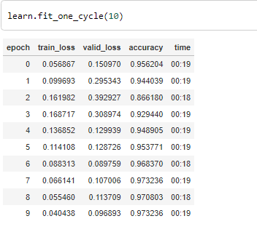

**Was there a case of overfitting in the model? Explain**

Overfitting in the Emergency Vehicle Identification project is a problem where a model performs well on training data but fails to generalize effectively to new data. The model may exhibit high training accuracy but low validation accuracy when evaluated on a separate validation set or new data. It can also result in a large performance gap, where the model's performance on the training set is significantly different from its performance on the validation set. Additionally, overfitting can occur when the model is too complex relative to the available data, leading to poor generalization. To mitigate overfitting, techniques like regularization, dropout, data augmentation, and early stopping can be employed. It is crucial to monitor the model's performance, analyze learning curves, and evaluate it on independent data to determine if overfitting has occurred and take appropriate steps to address it.

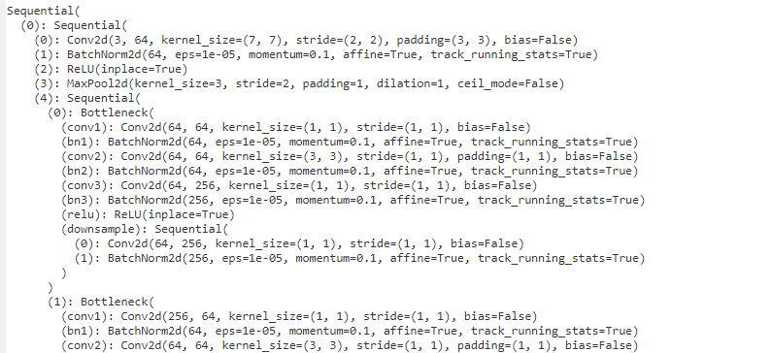

**State the performance measure(s) you were most interested in and the reason(s)**

The Emergency Vehicle Identification project requires an AI language model to evaluate its performance in identifying emergency vehicles. Common performance measures include accuracy, precision and recall, F1-score, and Receiver Operating Characteristic curve and Area Under the Curve (AUC). Accuracy measures the proportion of correctly classified samples, while precision measures the proportion of correctly identified emergency vehicles. Recall measures the proportion of correctly identified emergency vehicles out of all actual emergency vehicles. The choice of performance measures depends on the project's objectives and priorities, such as minimizing false positives or capturing as many emergency vehicles as possible. It is essential to consider the practical implications of the model's performance and select measures that align with the project's goals and requirements.

# **Component 4 Identify five ethical challenges in AI systems**

Ethical challenges in AI systems can arise due to various factors, including biased decision-making, privacy concerns, accountability, transparency, and the potential impact on employment. Here are five ethical challenges in AI systems along with relevant examples:

1. Bias and Discrimination:

AI systems can inadvertently reflect and perpetuate societal biases, leading to discriminatory outcomes. For example, if an AI-powered hiring system is trained on historical data that is biased against certain demographics, it may disproportionately reject qualified candidates from those groups.

2. Privacy and Data Protection:

AI systems often require access to large amounts of personal data, raising concerns about privacy and data protection. For instance, facial recognition technology used in public spaces may infringe upon individuals' privacy rights if their identities are tracked and stored without their consent.

3. Lack of Accountability:

AI systems can sometimes make decisions that have a significant impact on individuals' lives, yet they may lack transparency or accountability. For example, if an AI algorithm is used in the criminal justice system to predict recidivism rates, but the decision-making process of the algorithm is opaque, it becomes challenging to hold anyone accountable for erroneous or unfair outcomes.

4. Transparency and Explain ability:

The black-box nature of some AI models poses challenges in understanding and explaining their decision-making process. For instance, if an AI system is used to determine credit scores, individuals affected by the system may have difficulty understanding why they were given a particular score or how to improve it.

5. Impact on Employment:

AI automation has the potential to disrupt traditional job markets and lead to significant changes in employment. While AI can enhance productivity and create new opportunities, it may also lead to job displacement for certain professions. For example, autonomous vehicles could reduce the need for human drivers, impacting the livelihoods of many professional drivers.

Addressing these ethical challenges requires a multi-stakeholder approach involving policymakers, industry experts, ethicists, and the public. Striking a balance between innovation, fairness, privacy, and accountability is crucial to ensure AI systems are developed and deployed responsibly.